ANNEX B-5.1

WHOLESALE LINE RENTAL

Index
Index 2
1. General 3
2. Definitions 4
3. Scope and Service Description 5
4. Migration 8
5. Service Level, Maintenance, Fault Reporting And Repair 9
6. Relationship with End Users 10
7. Charges 11
8. Network Operations and Maintenance 12
2 Ordering and Delivery 13
3 Fault Managment 14

- General

This Annex sets out the Ooredoo offer for providing wholesale line rental services (“WLR Services”).
- Definitions

See Definitions in Annex A of the Agreement.

- Scope and Service Description

The Ooredoo portfolio of WLR Services is intended to facilitate access to public networks and connecting customers.

The Ooredoo WLR Services portfolio consists of the following services on Ooredoo’s fixed public telecommunication network in Oman:

3.2.1 Fixed line;

3.2.2 ISDN line; and

3.2.3 Associated facilities as defined in this Agreement.

The WLR Services are offered with the Access Seeker’s carrier pre-selection or call-by-call according to the technical and financial conditions in this Agreement.

The WLR Services are only provided to operator’s providing public switched telephone services to end users.

Numbers allocated to the WLR Services are those from Ooredoo’s number range of its national geographic numbering plan or numbers that have been ported to Ooredoo. The end user shall keep the number allocated to it throughout the Migration process while activating the WLR Services, while a number allocated to a WLR line cannot be ported out.

The technical conditions applicable to the WLR Services provision will be the same as the ones of the Fixed Line/ISDN services provided by Ooredoo to its retail customers.

The WLR Services are incompatible with the “Full Local Loop Unbundling” services.

The WLR Services shall only be provided on a telephone line where a network termination point (NTP) exists in the end user’s premises and where the necessary capacities are available.

Unconnected buildings may be connected, subject to prior survey and feasibility study, upon the building owner’s request addressed to Ooredoo, it being specified that the related costs shall be paid by the said requesting building owner, while once the building has been connected, the Access Seeker may further order WLR Services to Ooredoo.

The WLR Services and demarcation points applicable under this Agreement are shown in figure 1 hereafter. Ooredoo shall be responsible for the provision of WLR Services on Ooredoo’s public switched fixed telephone network up to the NTP located in end user’s premises. The services to be provided between Ooredoo’s public switched telephone network and the PoI will be provided by Ooredoo pursuant to this Agreement stipulations and related interconnect agreement signed with the Access Party. Ooredoo’s responsibilities end at the demarcation points, namely the PoI on one side and the NTP on the other side.
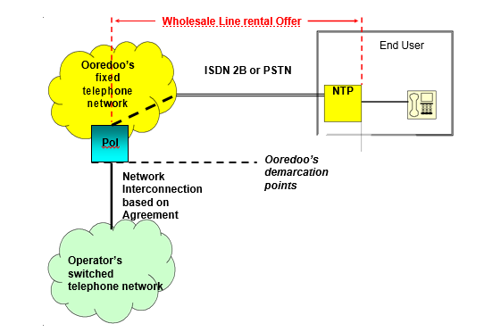
ISDN 2B or Fixed Line
Figure 1

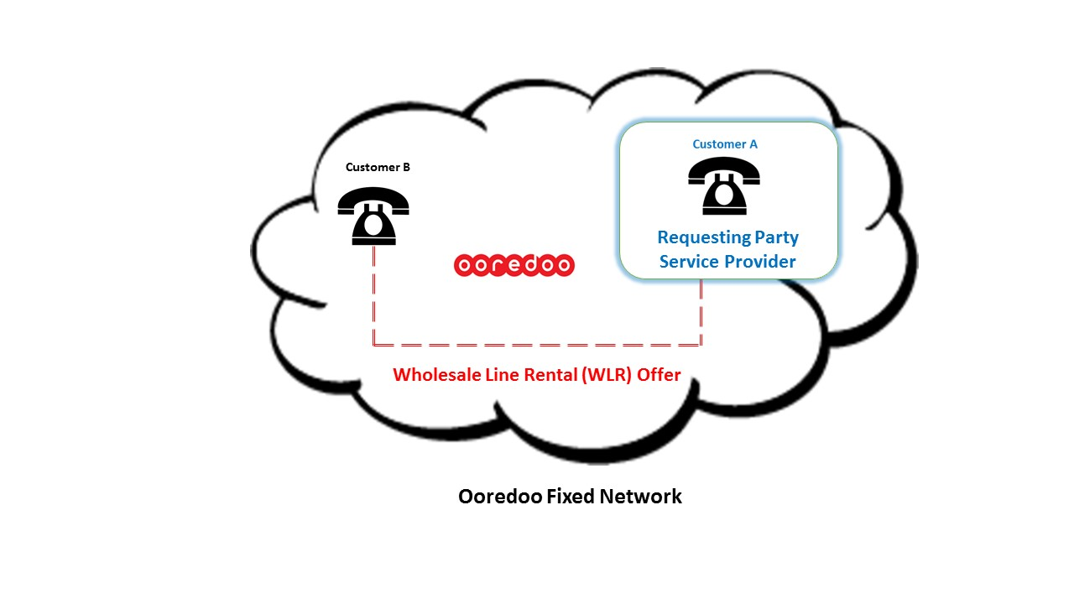

- Migration

4.1 For the Migration of existing WLR Services, the Receiving Operator has to prior agree in writing with the end user upon the Migration and the end user has to confirm in writing to the Receiving Operator that it cancels the current telephone access services provided by the Donor Operator in compliance with applicable contractual obligations between that end user and the Donor Operator. The Receiving Operator shall provide a copy of the above-mentioned confirmation to the Donor Operator upon its request.

For obtaining the effective Migration of the WLR Services from the Donor Operator to the Receiving Operator, the Receiving Operator shall order the Migration to Ooredoo in compliance with applicable procedures. The Donor Operator will be informed by Ooredoo of the cancellation of the WLR Services further to the achievement of the contemplated Migration.

- Service Level, Maintenance, Fault Reporting And Repair

The service levels, maintenance, and fault reporting, management and repair shall be as per the main body of the Agreement.

Ooredoo will not accept any fault report transmitted directly by seeking party’s end users and shall not be obliged in such case to inform the Access Seeker of such reported fault. Access Seeker has to inform the end user about its own responsibility in this respect as Access Seeker and communicate its own fault contact points to the end user in order to prevent any abuse of Ooredoo’s support services.

Prior to submitting any fault report, the Access Seeker shall ensure that a genuine fault exists and that every effort has been made to check that the fault resides within Ooredoo’s area of responsibility (i.e. on Ooredoo’s public switched fixed telephone network up to the NTP located in end user’s premises, excluding any end user’s installations and/or equipment).

- Relationship with End Users

The Access Seeker is entitled to resell the WLR Services under its own brand to its end users, but shall in no case use Ooredoo’s brand.

Ooredoo is allowed to use, for all actions taken pursuant to this Agreement, its normal vehicles and staff uniforms with all advertising on them as for its own products and services.

The Access Seeker is not allowed to attach any branding or advertising signs on Ooredoo’s equipment and infrastructure, notably in end user’s sites.

The Access Seeker has to inform Ooredoo immediately about the complete identity of the end users of the WLR Services as well as any changes thereto.

Without prejudice to the rights and obligations set out in the present Agreement, Ooredoo will not undertake customer handling/care of Access Seeker’s end users.

Without Ooredoo’s prior consent, the Access Seeker shall not publish or give to end users any of Ooredoo’s contact details, either as nominated by Ooredoo to the Access Seeker for the purpose of this Agreement and/or the WLR Services, or otherwise.

The Access Seeker is solely responsible for the contractual relationships with the end users, notably for the purposes of billing and customer handling.
- Charges
  - Charges are specified in the Annex F - Pricing.

- Network Operations and Maintenance
  - Refer to the Main Body of the Agreement.

9 Ordering and Delivery

The delivery time shall be no more than 30 Working Days for connectivity to each customer (assuming the site has been prepared for CPS routed call). This delivery date is subject to the Requesting Party having fully cooperated with Ooredoo and that there will be no delays caused by factors outside Ooredoo’s control such as, for example, due to the delay arising from the involvement of governmental entities.

All other ordering and delivery shall follow the process stipulated in the Main Body of the Agreement.

Fault Managment

10.1 Fault Management shall follow the process stipulated in the Agreement

